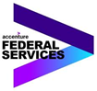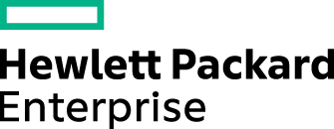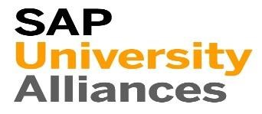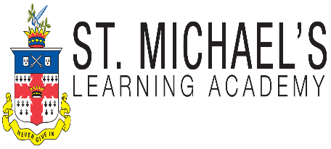

**www.stmichaelslearningacademy.com**

**Employers Who Hire Our**

**SAP Certified Students**

**SAP** Certification

**Tel 832.868.3067 | Email: certifications@stmichaelslearningacademy.com**

* **SAP Certification**

**June 11th**

* **PROJECT MANAGEMENT**  
  Offered monthly! bit.ly/SMLA-PMP
* A Certification can Strengthen You DEGREE and even improve your INCOME !!!!

**REGISTER TODAY!**